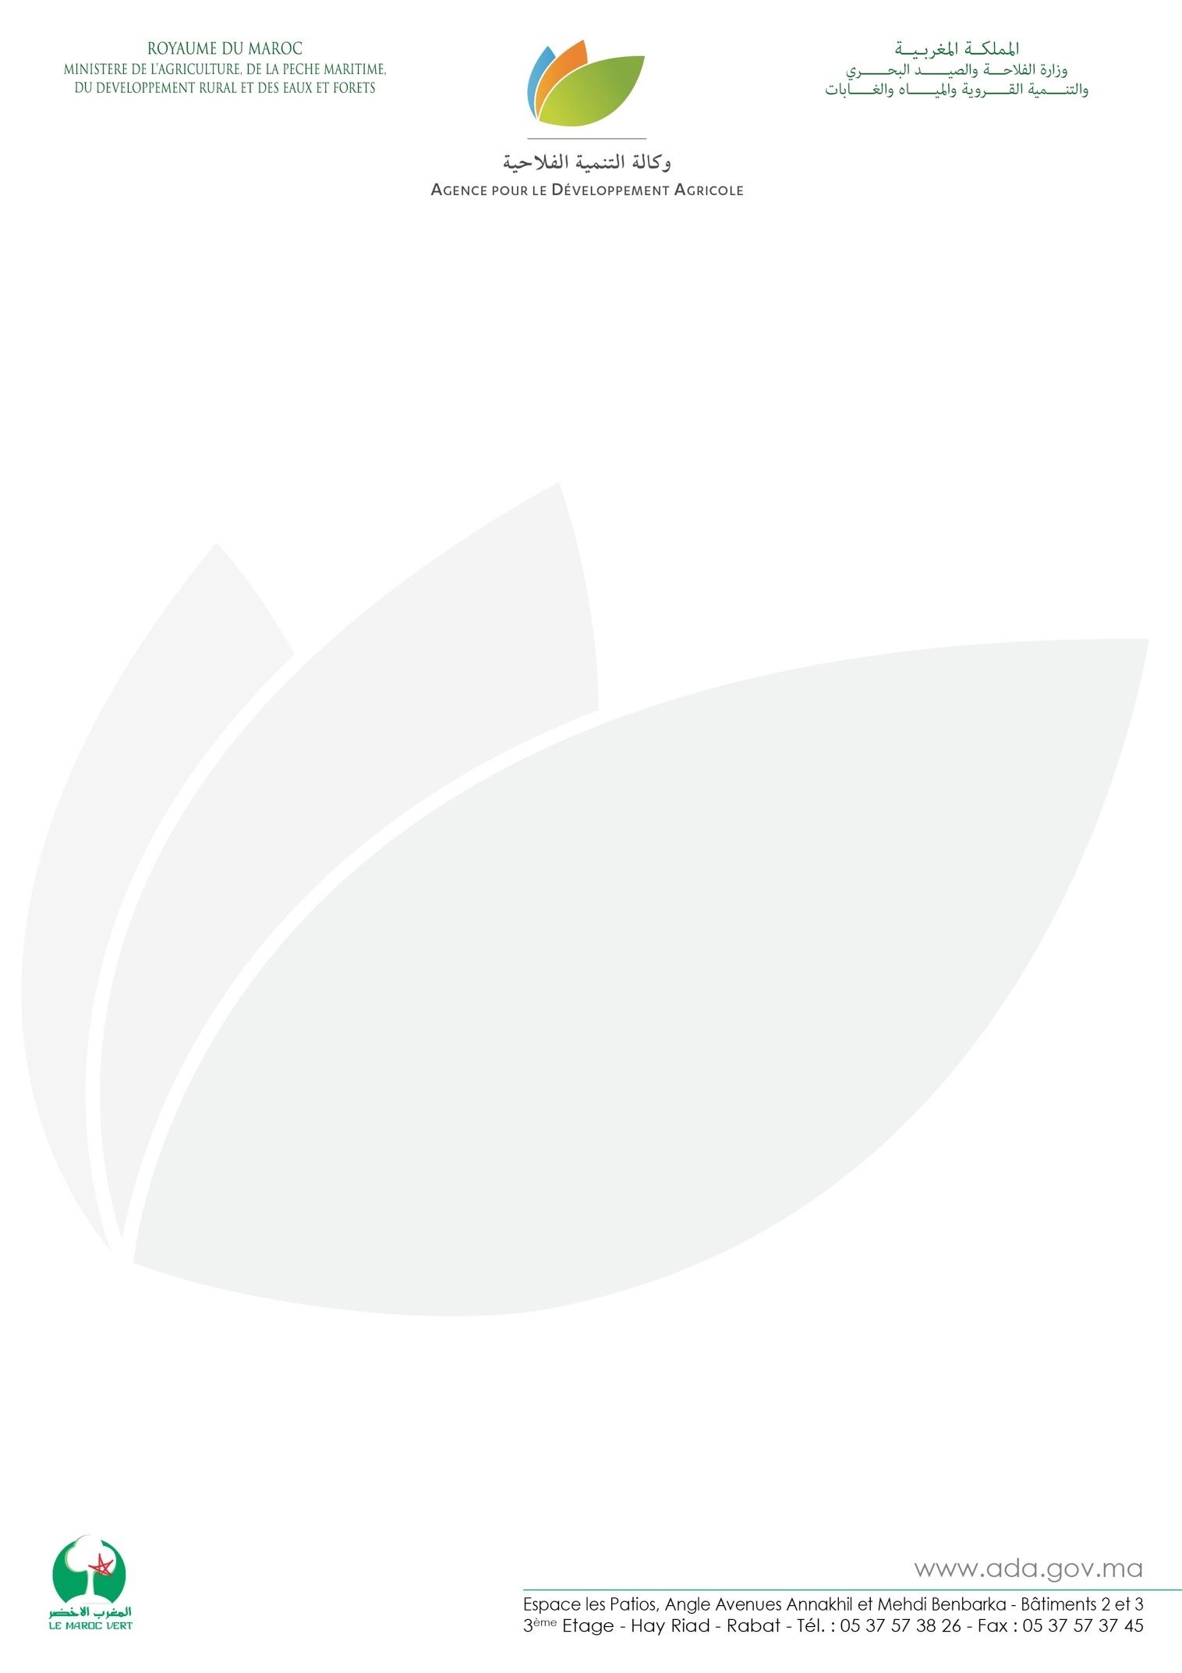

Press release
The marketing of local products is expanding
Essaouira, the 5th July 2019 - The Agency for Agricultural Development (ADA) is organizing a major seminar under the theme "Local Moroccan Products in Modern Marketing Circuits: Achievements and Perspectives".
An event that brings together the actors of the mass distribution, the agricultural cooperatives as well as all the actors of the department of agriculture concerned by the sector of the local products. The aim is to highlight the challenges faced by small producers of local products thanks to the efforts made by the ADA through the implementation of the strategy of development of the marketing of local products. This strategy focuses on improving competitiveness and access of local products to local and international markets. Supporting figures, the number of cooperatives supported by the ADA has reached 164 cooperatives that are continuously marketing their products at 113 large and medium-sized stores in 22 cities. These cooperatives, which have 5,935 members, 42% of whom are women, were able to double their sales and better referencing to the national market and especially to the level of modern marketing channels which guarantee a stable profitability and a better structuring of the sector.
Through this meeting, the ADA aims to show the importance of mass distribution in the national strategy of promotion and marketing of local products and its impact on the development and modernization of solidarity farming and to discuss the prospects future and the conditions for extending and sustaining the marketing of these products in modern distribution channels. Also, the goal is to raise awareness of the challenges of this strategy in terms of job creation and its contribution to the development of the agricultural world. The ADA intends to unite all partners to broaden the base of beneficiaries by supporting more cooperatives and increasing the market share of this segment and also to continue to develop new distribution channels.

