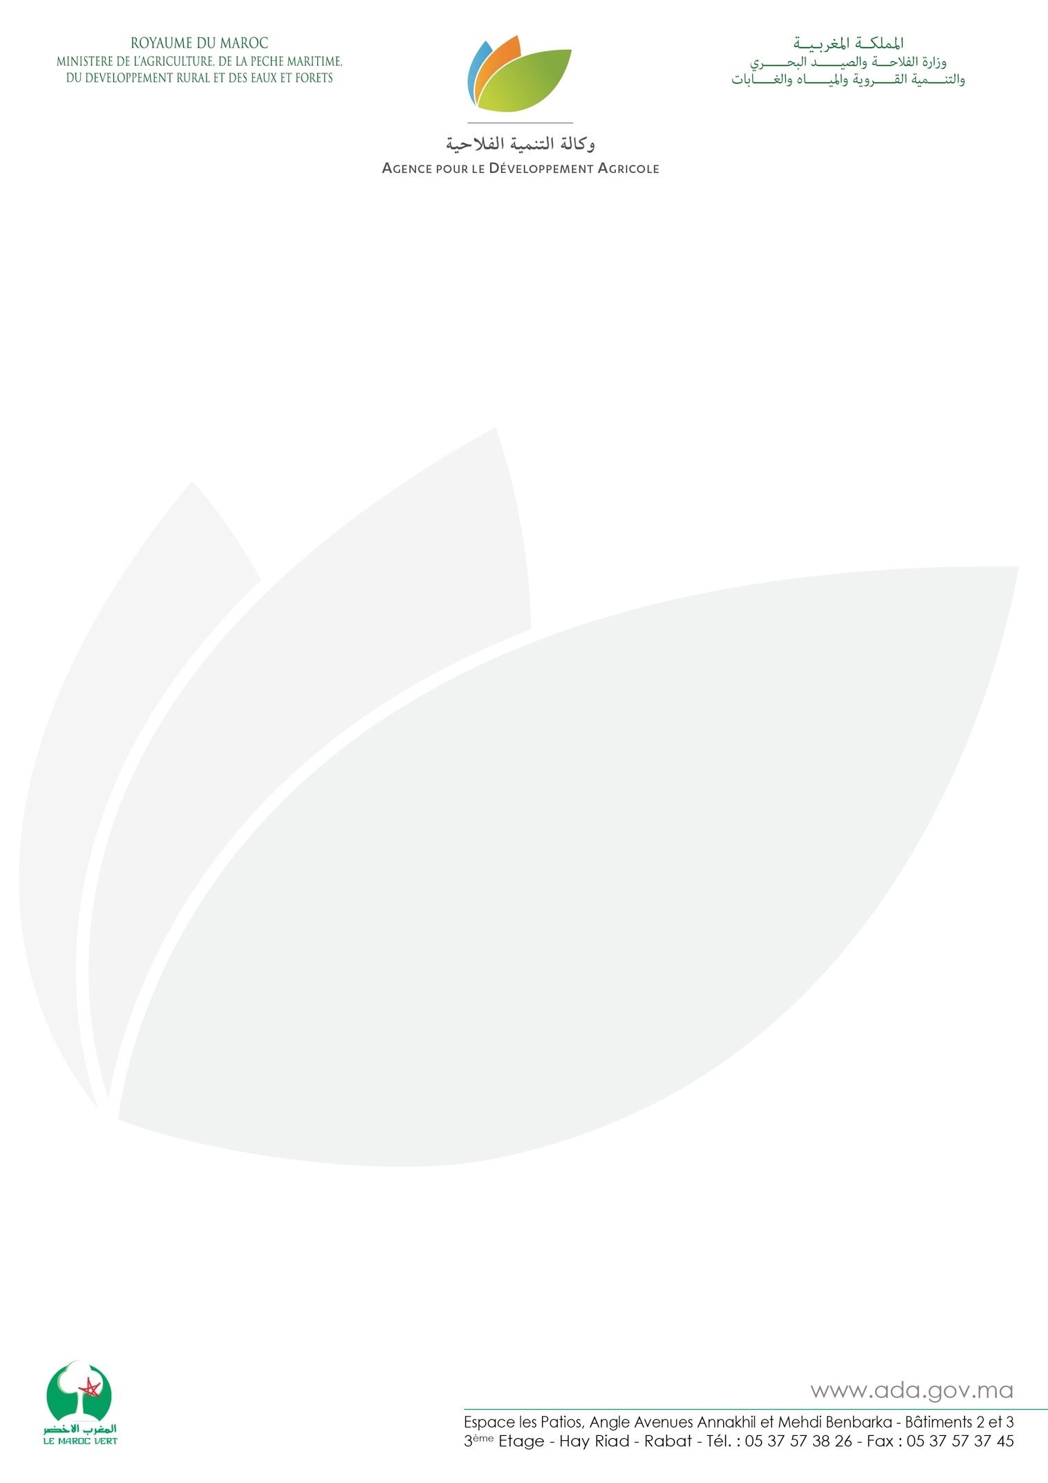

Press release
MOROCCAN LOCAL PRODUCTS BACK TO THE SIAP
After a successful participation in the 2018 edition, Morocco is back in force at the 56th edition of the Paris International Agricultural Show (SIA). Organized by the Agriculture Development Agency (ADA) for the seventh consecutive year, this participation is part of the ambitious strategy to promote the Moroccan local products, in line with the objectives of the Green Morocco Plan. It also aims to explore new opportunities for small Moroccan producers and to establish business contacts with major potential importers, so as to find new markets for this sector.
30 Moroccan agricultural cooperatives will travel to exhibit a hundred local products with high market value such as products labeled under AOP, PGI and under the collective label "TERROIR DU MAROC". These participants represent more than 1410 small farmers including 489 rural women from all regions of the Kingdom with a showcase of a multitude of local products, including Argane, olive oil, saffron, dates, aromatic and medicinal plants, spices, henna, etc.
These exhibitors have been selected on the basis of strict criteria, in particular the obtaining of the authorization / approval issued by the ONSSA (National Office for Sanitary Safety of Foods), the quality of their products and their packaging as well as the diversity of their ranges, to demonstrate the distinctive leap of the Moroccan offer to the 700,000 visitors expected during the 9 days of the show.
All these efforts by the Ministry of Agriculture, Maritime Fisheries, Rural Development and Water and Forests and the Agency for Agricultural Development, aim to support small farmers and producers to help them better market their products, with the ultimate goal of improving their incomes and living conditions. As such, intensive capacity building work was done prior to the event to properly prepare and adapt the offer of participants to the expectations of the French Market. The ADA also programmed more than 300 B2B meetings during this show to connect the Moroccan exhibitors with the potential actors of the market.
Combining tradition and modernity, the Moroccan Pavilion allows visitors to live a unique experience through its colors and flavors and to immerse oneself in Moroccan hospitality. The pavilion is also experiencing a series of culinary and cultural events, especially cooking shows and tastings of Moroccan dishes offering a real insight into the assets and richness of gastronomy and cultural heritage of Morocco.
Organized under the theme "Women, men, talents", the International Agricultural Show is considered the largest agricultural event in France for the general public, it hosts an average of 700 000 visitors and remains the essential gathering of the great cultures, the regional and international gastronomy, local products and breeding.

